[Real Life Applications of Differential Equations| Uses Of Differential Equations In Real Life](https://youtu.be/zm_UqjVLViU)

[](https://youtu.be/zm_UqjVLViU)

[What are differential equations?](https://youtu.be/QPm1BDJxadk)

[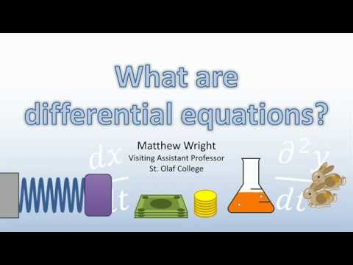](https://youtu.be/QPm1BDJxadk)